**Investment Summary: China Eastern Airlines Corp Ltd (600115.SS)**

As of: 5 September 2025  
Stock Price (previous close): 3.83 CNY  
Market Cap: Approx. 38 billion CNY  
Industry: Airline (Full-Service Carrier)  
Recommended Action: Hold

**Business Overview**

China Eastern Airlines Corp Ltd is one of China’s leading full-service carriers operating an extensive domestic and international route network. The airline offers passenger and cargo services, with a fleet of over 200 aircraft primarily comprising Boeing and Airbus models. In FY 2024, the airline generated revenue of RMB 132 billion, with a net loss of RMB 4.2 billion reflecting continued pandemic recovery challenges and elevated operating costs. The company also emphasizes sustainability, aiming to reduce carbon emissions and expand cargo capabilities, which contributed 20% of total revenue. It serves business and leisure travelers and logistics clients, leveraging strategic alliances and fleet modernization. Strengths include a broad route network and government backing; ongoing risks include fuel price volatility and high leverage.

**Business Performance**

* Revenue grew moderately from RMB 113 billion in 2023 to RMB 132 billion in 2024.
* Net losses narrowed significantly from RMB 8.3 billion in 2023 to RMB 4.2 billion in 2024.
* Operating cash flow improved substantially, supporting fleet expansions and debt servicing.
* Market share is strong domestically, competing with China Southern and Air China.

**Industry Context**

* The airline industry is in a recovery phase post-pandemic, with domestic demand rebounding faster than international.
* China’s aviation market is expected to grow at ~7% CAGR in coming years.
* China Eastern aims to expand cargo operations and sustainable aviation practices to stay competitive.
* Debt levels remain elevated relative to industry peers due to previous pandemic impacts.
* Future return on equity is forecast at 13.9%, indicating improving operational profitability.

**Financial Stability and Debt Levels**

The airline currently has a high net gearing ratio (~6.3x), reflecting significant leverage due to pandemic-related losses and fleet investments. However, liquidity is supported by stable cash flows from expanding operations and capital injections. Interest expenses remain substantial but manageable thanks to debt restructuring and hedging measures. Financial health is expected to improve but remains a risk factor.

**Key Financials and Valuation**

* FY 2024 revenue: RMB 132 billion, with expectations to grow to RMB 140 billion in 2025.
* Net loss in 2024 was RMB 4.2 billion, with projections for returning to profitability in the next 2-3 years.
* Current P/E is negative due to losses; DCF valuation suggests intrinsic value around 3.33 CNY vs market price of 3.83 CNY.
* Dividend is currently suspended due to financial recovery phase.
* Industry relevant metrics include a load factor close to 80%, slightly below pre-pandemic averages.

**Big Trends and Events**

* Fleet modernization and international route expansions drive future growth.
* Elevated jet fuel prices without effective hedging pose margin risks.
* Implementation of sustainable aviation goals to reduce carbon footprint.
* Recovery of cargo and passenger demand critical for earnings turnaround.

**Customer Segments and Demand Trends**

* Major segments: Business travelers, leisure travelers, cargo/logistics customers.
* Growth driven by increasing domestic air travel and gradual reopening of international routes.
* Demand remains sensitive to economic conditions and geopolitical tensions.

**Competitive Landscape**

* Significant competition with China Southern and Air China; alliances through SkyTeam supports network strength.
* Moats include fleet size, route breadth, and government support.
* Key competition battlegrounds: fleet efficiency, customer experience, cargo services.

**Risks and Anomalies**

* High leverage and persistent losses increase refinancing risks.
* Fuel cost volatility and regulatory constraints impact operational costs.
* Operational risks remain related to travel demand fluctuations.

**Forecast and Outlook**

* Expected return to profitability within 3 years driven by revenue growth and cost controls.
* Fleet expansion and sustainable aviation investments critical to long-term growth.
* Earnings growth projected around 90% per annum in near future albeit from loss positions.

**Leading Investment Firms and Views**

* Analysts largely hold a cautious stance with Hold ratings and modest price targets near intrinsic valuations.
* Some bullish views based on recovery and fleet modernization optimism.

**Recommended Action: Hold**

Pros:

* Strong market position with plans for sustainable growth.
* Improved revenue and cash flow trends.
* Strategic fleet and cargo expansion support.

Cons:

* High leverage and losses constrain near-term financial flexibility.
* Exposure to volatile fuel prices and operational risks.
* Uncertainty in international travel recovery pace.

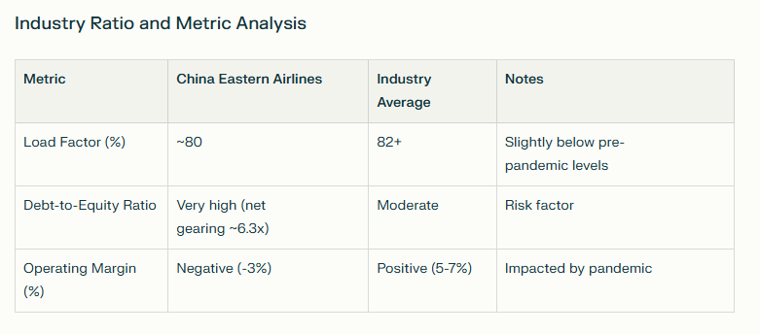

**Key Takeaways**

China Eastern Airlines is navigating the post-pandemic recovery through revenue growth, fleet upgrades, and operational improvements. Elevated debt and ongoing losses moderate the investment outlook, positioning this stock as a Hold while focusing on financial stabilization and return to profitability. Investors should monitor leverage trends, fuel costs, and international market conditions.

**Sources**

* [China Eastern Airlines 2025 Q1 Report](https://www.ceair.com/global/en_static/AboutChinaEasternAirlines/intoEasternAirlines/InvestorRelations/announcement/HongKongStockExchange/hkExcReleased2025_1/202504/P020250430317269571774.pdf)
* [SimplyWall St Analyst Forecasts](https://simplywall.st/stocks/cn/transportation/shse-600115/china-eastern-airlines-shares/future)
* [Investing.com Financials](https://www.investing.com/equities/china-east-air-ss-financial-summary)
* [Reuters Company Profile](https://www.reuters.com/markets/companies/600115.SS)
* [ValueInvesting.io DCF Valuation](https://valueinvesting.io/600115.SS/valuation/dcf-growth-exit-5y)